**What Are The Dangers Of Disposing Of Assets In-House?**

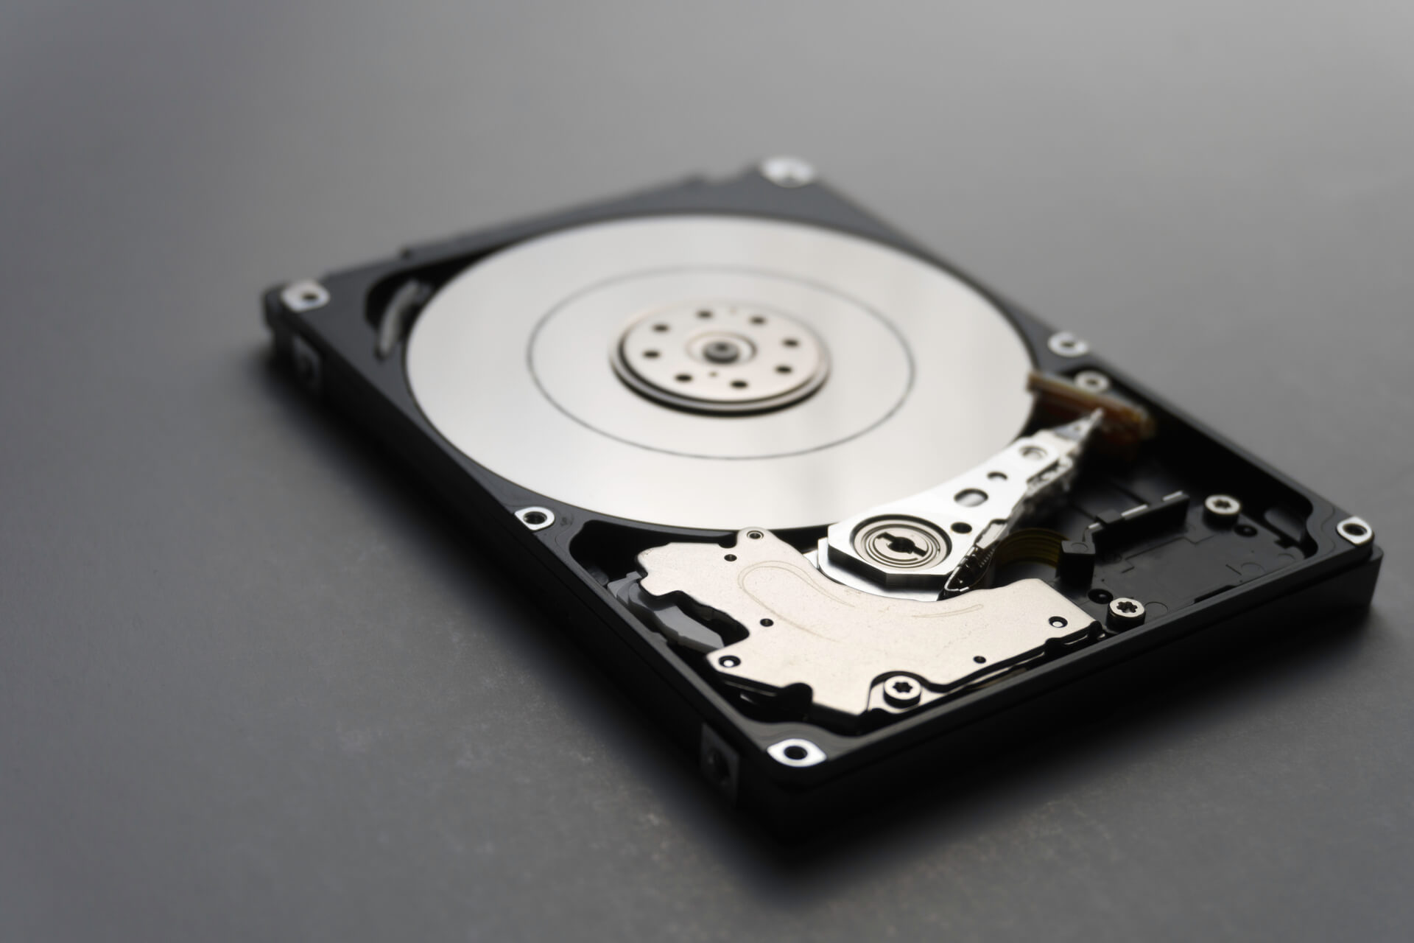

If your company is ready to get rid of outdated computer equipment or hardware, it will need to be wiped clean and prepared for a new user, regardless of where it goes.

Unfortunately, some business owners believe that clearing the slate is as simple as pressing the delete key. In-house asset disposition, on the other hand, can be one of the most costly blunders a firm can make at such a critical shift.

Here are three of the most important reasons why you should never risk in-house asset disposition, ranging from financial disaster to downright reputation destroying mistakes.

**Non-Compliance**

Your hard drives may contain sensitive information about clients if your company works in the financial, healthcare, education or healthcare industries. Proper preparation for disposition often involves copying or transferring valuable data onto a new drive.

Although most companies are able to accomplish this aspect of disposition, many people forget that valuable data may still be on old equipment.

Your customers don't have the right to take their old hard drives back and smash them with a blunt object. Several industries require professional asset disposition services in order to ensure HIPAA, FACTA and PCI data are disposed within the federal and industry standards.

If this information is not protected, customers could find out about it and damage your brand's reputation.

**Environmental Damage**

In-house disposal is typically placed in the hands of a company's IT team, and it carries the risk of being handled incorrectly. Your in-house crew may dispose of your electronics at a local landfill without your knowledge.

This action contributes directly to the millions of tonnes of e-waste that pollute the environment each year. Furthermore, if a corporation is caught red-handed, this form of disposal could result in costly implications.

**Data Breach Costs a Lot of Money**

One of the most typical difficulties a firm experiences during an electronic transformation is data breaches. When your sensitive data falls into the wrong hands, ransom or outright digital theft can occur, and your company will lose money in either case.

The global average cost of a data breach, according to IBM data, is $3.86 million dollars. Any data breach, regardless of how well-established your company is, requires additional expenditures.

Unfortunately, unless your equipment is thoroughly cleared by a skilled asset disposal company like Recycle Pro, even physically broken gear can be cobbled together and vital data recovered.

**What Are the Benefits of Asset Disposition Services?**

Don't put your company's finances and image at danger by selling assets in-house. Recycle Pro has the expertise to appropriately dispose of your company's data. We offer Certified Erasure, which ensures that your extremely sensitive data is completely erased.

In addition to secure erasure, we ensure an environmentally responsible approach that decreases your brand's environmental footprint. Trust us to assist you in making the most simple and effective selections possible as you transition to emerging technologies.

**With Recycle Pro, clean the slate on your hardware.**

If you’re ready to invest in new technology but need to responsibly dispose of your old assets, Recycle Pro can help. To learn more about the advantages of our asset disposition service and other recycling options, [contact us](https://www.recyclepro.co.uk/) today.